**Quiz 1 Review**

1. Identify the point(s), line(s), and plane(s) in the figure. Use proper notation. Separate items in each list with commas.

Points:

Lines:

Planes:



**2)** Name each geometric figure.

a) b) c)

  

**3)** If *EF* = *x* + 7, *FG* = 4*x* – 9 and *EG* = 35, find the values of *x*, *EF*, and *FG*

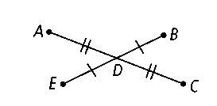**5)** If *DC* = 6*x* and *DA* = 4*x* + 18, find the value of *x.* Then find *AD, DC,* and *AC.*

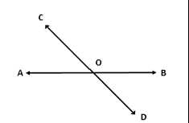**6)** *AB* bisects *CD.* If *CD* = 4*y* − 12 and *CO* = *y* + 17, find the value of *y.* Then find *CO, OD, and CD.*

**5)** Given the figure and measures of the two angles, solve for *x*.

$4x+1 x-21$

****4)** Ray BD bisects ∠*ABC*. m∠*ABD* = 2x + 3 and m∠*DBC* = 7x – 7.

Find the measure of ∠*ABD,* ∠*DBC,* and ∠*ABC.*

**7)** Construct a line segment congruent to the given line segment below.



**8)** Construct an angle congruent to the given angle below.

